Vocabulary Lesson Plan

Lesson focus information
Lesson focus | [What will you be covering?]
Examples | [Example words]
Extra information | [Identify any additional learnings that will take place]
Grade levels | [Insert grade/year]
Curriculum links | [Note any specific curriculum points you will cover]
Lesson differentiation
Whole class and group activities | [Explain any whole class or group activities that will be a part of the lesson and why they are important]

Vocabulary Lesson Plan

Lesson differentiation
Independent activities | [Explain what independent activities your students will be undertaking]
Recommended word lists (available in Readiwriter Spelling)
Entry level |  | Core level | Exit level
[list words here] |  | [list words here] | [list words here]

Vocabulary Lesson Plan

Motivate
[How will you motivate your students to spark a deep self-driven love of learning? Examples below.]
Joke spot
Telling jokes is a great way to engage students and focus them on the lesson. It also provides avenues to explore the double meanings of words.
- For example, Engage the students by asking some jokes involving number prefix words if that Is what you are teaching:
  - Why couldn’t the bicycle compete in the tricycle race?
Because it was two-tyred.
  - What do you say when you chase the person who stole your tricycle?
Whe-el whe-el whe-el ...
  - How does an octopus propose?
“I’d like to ask for your hand, hand, hand, hand, hand, hand, hand, hand.”
  - What did the triangle say to offend the circle?
You’re pointless!
- Discuss the jokes and why they are ‘funny’.
How are these words connected?
Allowing students to make their own links between the words can be more effective than just providing them. Introduce this concept through exploration, discussion and discovery.
- For example, display or print a set of pictures of tri- words such as the set below.

- Use the think-pair-share strategy to give students an opportunity to consider what the pictures have in common.
- Through discussion, establish that the pictures are all linked to the number ‘three’.
- Explain that Greek and Latin number prefixes are the focus of this lesson and that understanding the meanings of the prefixes can help with spelling and vocabulary building.

Vocabulary Lesson Plan

Motivate
Learning intention
[Provide a learning intention statement. Example below.]

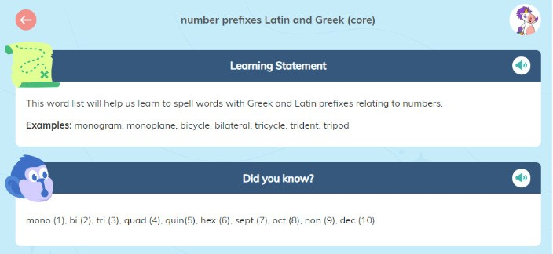

Model
[How will you provide clear and explicit explanations of the lesson focus? Examples below.]
Word pictures (tri- words)
Associating words with their definition is an important connection. This can be enhanced further by incorporating visual stimuli.
- Using the word pictures, ask students if they know the word each picture represents.
- Provide dictionaries to establish the names and definitions of any unknown words.
- Depending on the support required, use printed words and definitions (or allow confident students to create their own) to develop a complete set of words, pictures and definitions:
 | TRILOGY | A series of three books

Vocabulary Lesson Plan

Model
- Learning summary:
  - The prefix tri- comes from both Greek and Latin origins.
  - Confirm that tri- means three.
  - Address the misconception that all words beginning with the letters ‘tri’ relate to three. For example, trick, trip, tried.

Word tree
A word tree shows commonality in a set of words. It is an excellent visual tool for establishing connections and also serves as a memory aid when displayed in the classroom.
Use the word, picture and/or definition cards to create a tri- word tree:

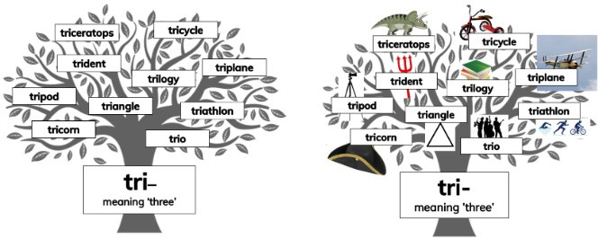

Making sentences
Using new vocabulary in context is critical to making connections and empowering students to use the words in speaking and writing.
- Use the words in sentences and contexts that are meaningful to your students.
- Provide a wide range of examples to give everyone an opportunity to connect and relate to the word.
- Have students attempt to articulate their own examples of the word in context. By including this in the explicit teaching phase, there are opportunities to clarify understanding when words have multiple meanings and deal with any misconceptions.

Vocabulary Lesson Plan

Master
[How will students master their learnings through appropriate practice and support? Example below]
Applying learning
Once students understand the use and origin of one number prefix, they are ready to explore other similar prefixes.
- Explain that many number prefixes come from Greek and Latin origins. Some are used more commonly than others.
- Provide a set of words with Greek and Latin number prefixes and allow students time to make themselves familiar with the words and meanings.
- Use knowledge from the word lists to create a table of number prefixes that can be added to throughout the unit of work.
- Through discussion, establish which prefixes are more commonly used and highlight them on the chart. A completed table may look like this:

Number Greek Latin
  - mono uni
  - di or dy bi or duo
  - tri tri
  - tetra quadri or quart
  - penta quinque or quint
  - hex sext or se
  - hept sept
  - oct oct
  - ennea nonus or novem
  - dec dec or de
Magnify
[How will I extend my students’ learning and support them as they apply understanding? Examples below.]
Expanding knowledge
- Have students choose a number prefix to investigate further.
- Provide fact cards to record information gathered about each word in the word family.
- Create a new word tree using the blank word tree template on page 11.

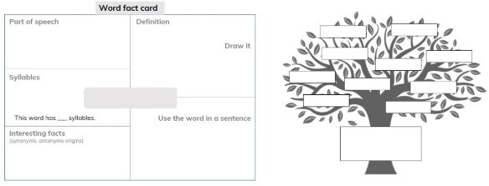

Vocabulary Lesson Plan

Months of the Year
- Explain that several months of the year include a number prefix yet the number does not relate to the position of the month in the year. September comes from ‘sept’ meaning ‘seven’, yet it is the ninth month of the year.
- Have students investigate the origins of the months of the year – September, October, November and December – and why their number prefix is incorrect.
- Investigate the other months of the year to determine their origins.
Meaningful feedback
[How will I provide meaningful feedback both immediately and over time?]

Gathering data
- The best indication that students have learned new vocabulary is when they use and understand these words in reading, writing, speaking and listening.
- Provide opportunities for students to demonstrate their understanding in multiple contexts.
- Celebrate the correct use of word rule in all communication.
- There are also strong links between spelling knowledge and vocabulary.
- Pre-tests and post-tests can be helpful in guiding teaching, tracking progress and informing future steps.
- Monitor student achievement throughout the unit of work and adjust grouping, goals and instruction to meet the changing needs.

Vocabulary Lesson Plan

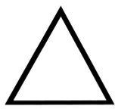

Vocabulary Lesson Plan

triceratops | tricycle
trident | triplane
trilogy | tripod
triangle | triathlon
tricorn | trio
a dinosaur with three horns | a three-wheeled vehicle
a spear with three teeth or prongs | a plane with three wings
a series of three books | a three-legged stand
a shape with three angles and sides | a race with three different events
a hat with three sides | a group or set of three

Vocabulary Lesson Plan

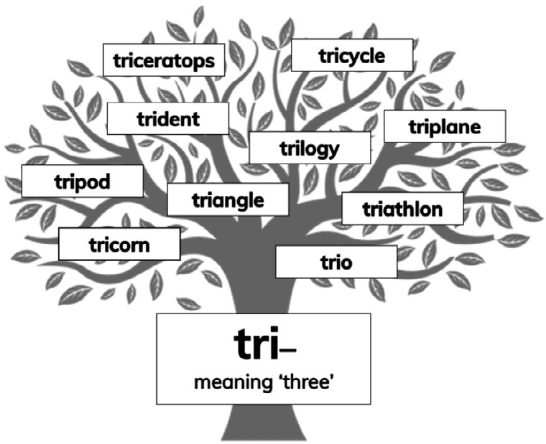

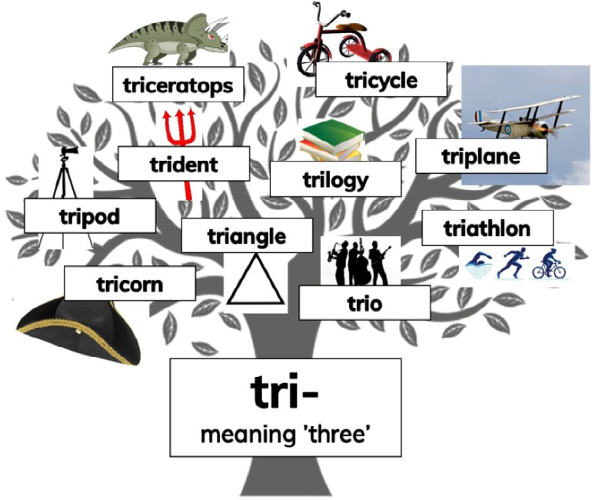

Vocabulary Lesson Plan

